Hi,

I implemented an application as per requirement. In this application I created 3 pages are

1. **Home**  (URL : <http://localhost:3001/#/Home>)

It’s a main (default) page of application startup.

1. **ThirdAPI** (URL : <http://localhost:3001/#/ThirdAPI> )

If the user click the “ThirdAPI” tab, it will call the google map (Third party API) API and the response (Google Map) rendering in this page. In this google map I pointed Hong Kong as a default location, suppose if you want to find any other location on the google map, just enter the location (Hong Kong, Shenzhen, Japan, India, etc.) on a text box.

Feature:

1. The user can search any location using this map

2. Key passed value pop-up (List out the option location) in the search text box.

3. Map Zoom-In and Zoom-Out option also included.

1. **RestCall** (URL : <http://localhost:3001/#/RestCall> )

This is the 3rd page of my application, here I call one third party Rest API when user click the “RestCall” URL and render the response into this page.

Suppose if the user enters the wrong URL into the browser and it will return “Page Not Found (404). So we already handle the 404 page exception.

Feature:

1. I show the progress-bar on view page up to loading the data from Rest API.

Test Case:

Here I used Mocha and karma to write test cases.

Application Screen Shot

1 Home Page

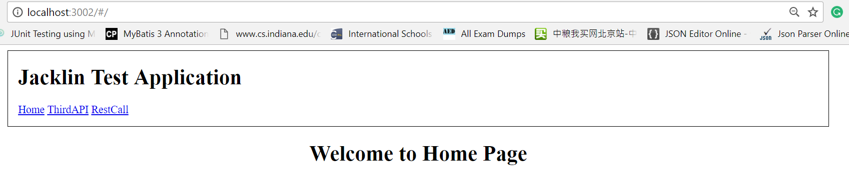

2. ThirdAPI Page

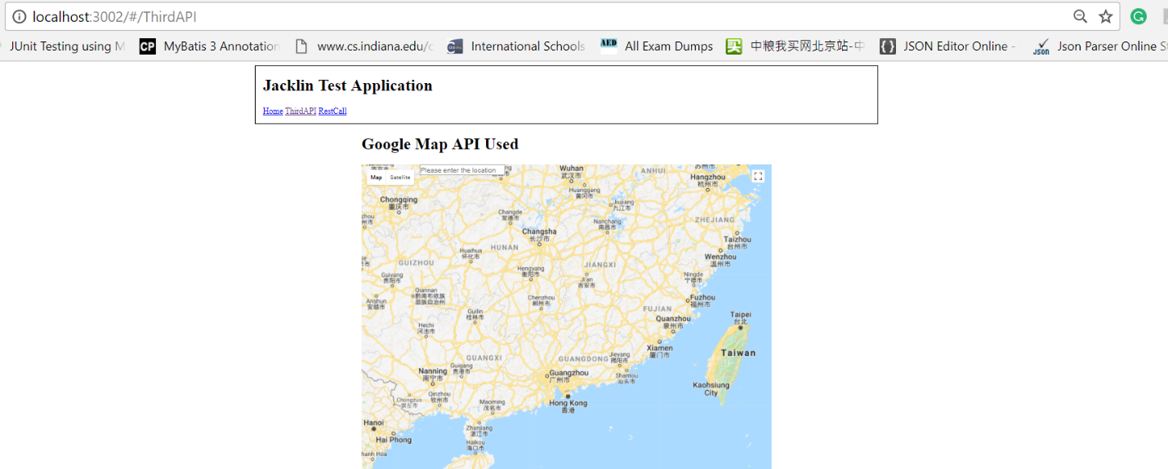

2.1 Pou-up Location

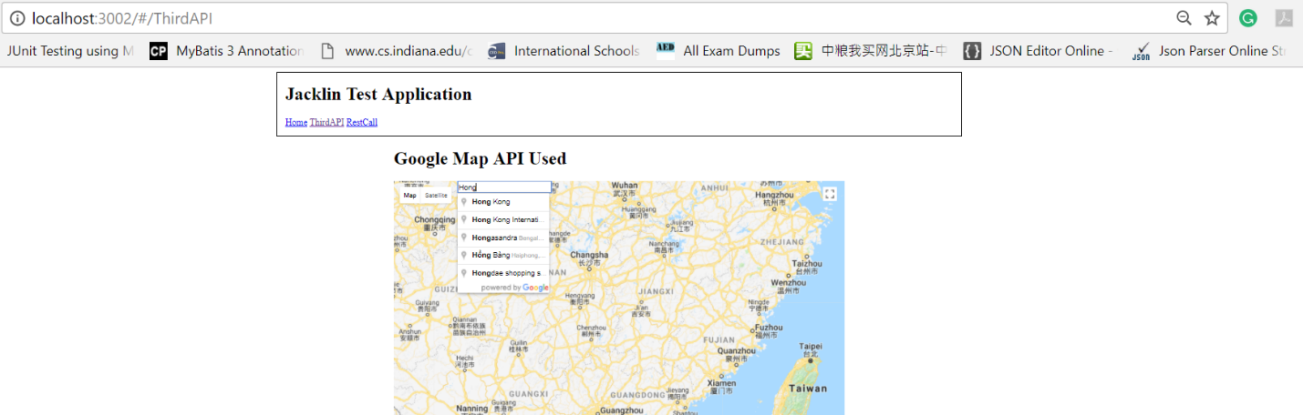

2.2 Location map

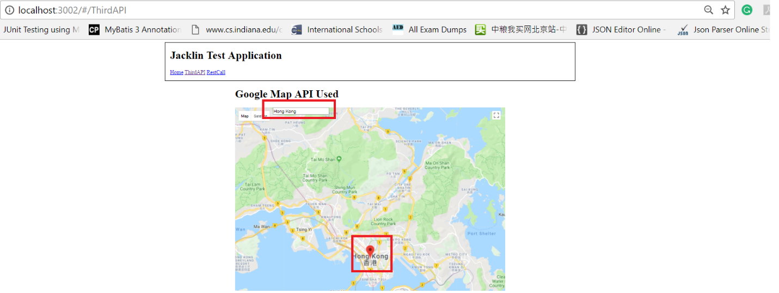

3. RestAPI Page (<http://localhost:3002/#/RestCall> )

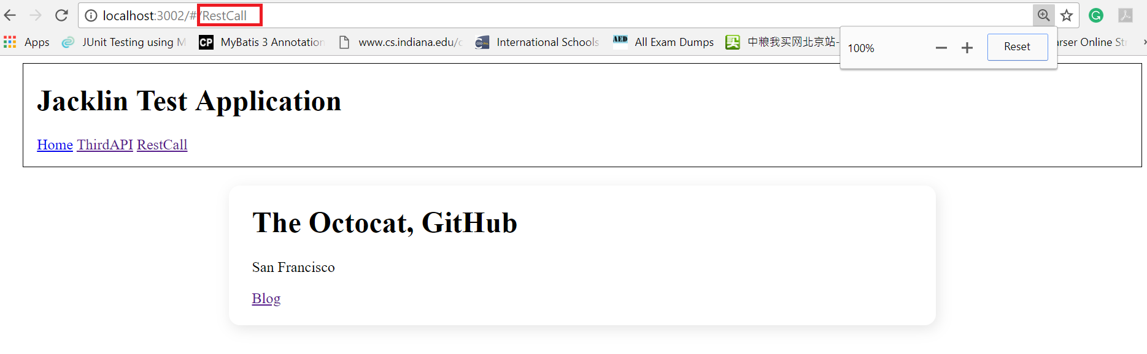

3.1 404 Page exception handling

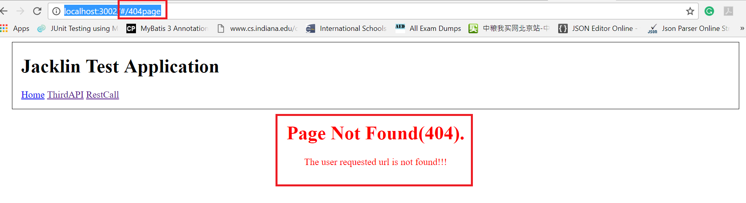

3.2 Test cases

